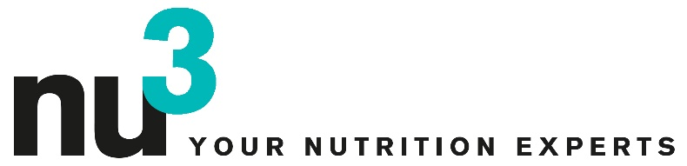

PRESS RELEASE

nu3 launches own brand

Berlin, February 6, 2012. Company nu3 GmbH, Europe’s market leader for intelligent nutrition, now markets products from their own brand which carries the same name.

Dr. Robert Sünderhauf, founder and CEO of nu3: “We are happy to now also offer products from our own brand. As nutrition experts it is our personal mission to supply our customers with innovative and high-quality products.” By launching a multitude of products under their own brand, nu3 can now implement these high standards even
better.
Their own brand products extends the product line of the online shop at the same time as strengthening the products offered in the field of intelligent nutrition. The first products to be launched are Goji berries, hyaluronic acid capsules, 5-HTP capsules as well as chlorella tablets of certified ecologic and Naturland quality.
The products of the own brand are drafted and produced by in-house developers. The production takes place almost entirely in Germany. Packaging quality and sustainability also play an important role. “nu3 is bound to the different quality principles. The excellence of our goods and the entire production processes are subject to very strict inspections.” says Dr. Sünderhauf.
Another goal of brand politics is to pass cost advantages on production side, and lower prices on to the consumer. Regarding the future, the product line is to be expanded further introducing nature foods and sport products.

Press contact:

Michael A. P. Divé
Head of Communications
Email: michael.dive@nu3.de
Phone: +49 (0) 30 / 340 443 857

About nu3 – YOUR NUTRITION EXPERTS

nu3 is Europe’s leading vendor for intelligent nurtition. Within the online shop customers find
the right product in line with their goal and philosophy in the areas of slimming, nature foods,
sports, health and beauty. The nu3 team of experts consisting of ecotrophologists, sport
scientists and physicians is constantly searching for innovative products for the growing line
of products with currently around 6.500 items. Berlin-based company nu3 GmbH was
founded in 2011 by Felix Kaiser, Kassian Ortner and Dr. Robert Sünderhauf. nu3 has around
120 employees and is active in nine countries. https://www.nu3.com

